

CTIS 2020/21 SENIOR PROJECT II

Team 3: ELIXIR

**FINAL INCREMENT**

**Team Members: Project Supervisor:**

Berk Özdoruk Dr. Cüneyt Sevgi

Erdoğan Yağız Şahin

Oğuzhan Özkan

Ömer Levent Durdalı





**TEST DATA FOR FINAL INCREMENT**

**Farm Details**

|  |  |  |  |  |  |  |  |
| --- | --- | --- | --- | --- | --- | --- | --- |
| **Name** | **Province** | **District** | **Latitude** | **Longitude** | **Daily Station No** | **Hourly Station No** | **Soil Type** |
| **ank-polatli-01** | Ankara | Polatlı | 39.913727 | 32.852128 | 90601 | 17130 | Silt Loam |

**User Details**

|  |  |  |
| --- | --- | --- |
| **Name** | **E-Mail Address** | **Password** |
| **AdminUserTest** | admin@admin.com | AdminAdmin |

|  |  |  |  |
| --- | --- | --- | --- |
| **Name** | **Farm** | **E-Mail Address** | **Password** |
| **Cüneyt Sevgi** | ank-polatli-01 | best@best.com | finalfinal |

**Crop Details**

|  |  |
| --- | --- |
| **Name** | Tomato |
| **Soil Moisture Min Percentage** | 60 |
| **Soil Moisture Max Percentage** | 70 |
| **Temp Min Celsius** | -1 |
| **Temp Max Celsius** | 35 |
| **Ideal Min Temp Celsius** | 19 |
| **Ideal Max Temp Celsius** | 25 |

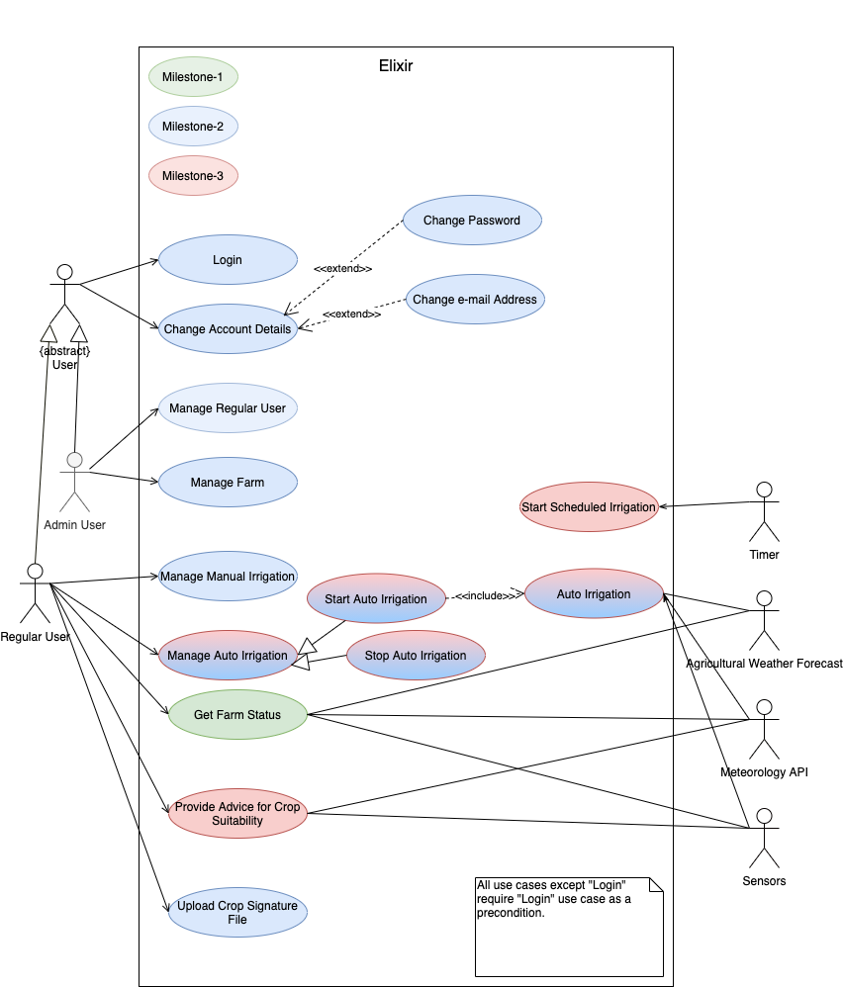

**SCENARIO FOR FINAL INCREMENT**

**Login with Regular User**

* + Home user Page
  + Go to Status Page
  + Go to Crop Page
  + Go to Irrigation Page
  + Start Scheduled Irrigation
  + Start Auto Irrigation
  + Go to Upload Crop Signature Page
  + Upload Crop Signature to the system
  + Go to Crop Page
  + Go to Irrigation Page & Start Auto Irrigation
  + Change User Account Details